**TASK-2**

Name: J. DHANUSH Section-2

Roll no: 2420090042

**Execute the following Network commands like ipconfig, tracert, telnet, netsh, ping, nslookup and netstat**

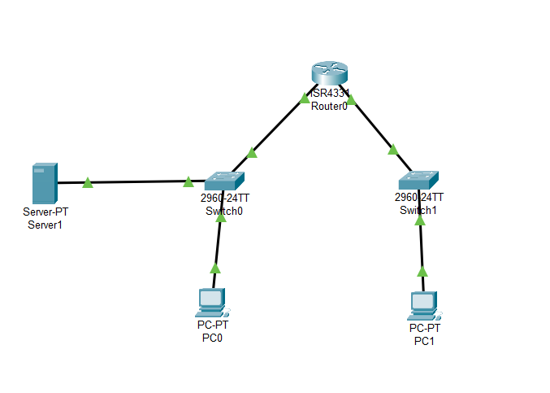

Step-1: Launch Cisco Packet Tracer.

Double click the Cisco packet Tracer icon on your Desktop or find it in your applications list and open the program

STEP-2: Create a simple network topology.

1. Add Devices:
2. Routers and Switches:

Drag and Drop a Router and a switch from the device list on to the

Workspace.

1. PC:  
    Drag and drop 2 PC’s on to the workspace.
2. Connect Devices:

Use the connection tool to connect the devices:

1. Connect 1 PC to the switch using the copper straight-through cable.
2. Connect the switch to the router using another copper straight-through cable
3. Connect the second PC to the switch using copper straight-through cable.
4. Configure devices:
5. Configure the router:

Click on the router, go to config tab. Assign IP address to the router interfaces ex: For PC-0:

interface G0/0: IP address: 192.168.1.1

subnet mask: 255.255.255.0

For PC-1:

interface G0/0: IP address: 192.168.2.1

subnet mask: 255.255.255.0

1. Configure the PC:
2. Click on each PC, go to the Desktop Option and then click on IP configuration.
3. Assign IP addresses to each PC. Ex:

PC-0:

IP address: 192.168.1.2

Subnet mask: 255.255.255.0

Default Gateway: 92.168.1.1

PC-1:

IP address: 192.168.2.2

Subnet mask: 255.255.255.0

Default Gateway: 92.168.2.1

1. Execute networking Commands:
2. Open the **Command Prompt** on PC-0:

Click on PC-0, go to **Desktop**, click on **Command Prompt**.

1. Tracert: This command traces the path taken to a destination by sending ICMP echo request messages

1. telnet: 1. Open **Command Prompt**:

On the PC-0, go to the **Desktop** tab and open the **Command Prompt**

2. Execute Telnet Command.

telnet <destination IP> <port>

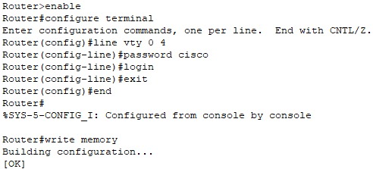

1. ip interface brief:

* Router configuration and Brief Ip Interface

This command is a scripting utility that allows you to display or modify the

network configuration of a computer.

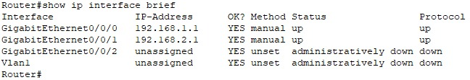

1. ping:

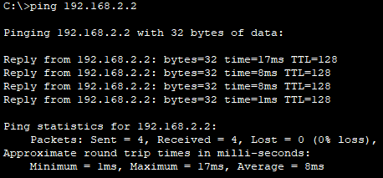

1. Nslookup:

**I. Assign IP Address:**

1) Click on the server.

2) Go to the **Config tab** and select the FastEthernetO interface.

3) Assign **IP address**: 192.168.1.3

**Subnet Mask**: 255.255.255.0

**Default Gateway**: 192.168.1.1

**II. Configure DNS Service:**

1. Go to the **Services** tab on the server.
2. Select **DNS** and turn the service On.
3. Add an entry for **www.google.com** with an IP address (e.g., 8.8.8.8).

**III. Use nslookup command:**

1.Open **Command Pro**mpt on PC-0.

2. Go to the **Desktop** tab on PC-0.

3. Open the **Command Prompt**.

1. Execute the nslookup Command.

nslookup www.google.com

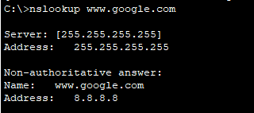

1. Netstst:

* This command displays network connections for the Transmission Control Protocol (TCP), routing tables, and a number of network interface and network protocol statistics.
* The netstat command is used to display network connections, routing tables, interface statistics, masquerade connections, and multicast memberships.

